**Name:- Dharan Gowda Superset id:-6387532**

**Create a React App named “bloggerapp” in with 3 components.**

1. **Book Details**
2. **Blog Details**
3. **Course Details**

**Implement this with as many ways possible of Conditional Rendering.**

**Step 1:- Create a react project(bloggerapp)**

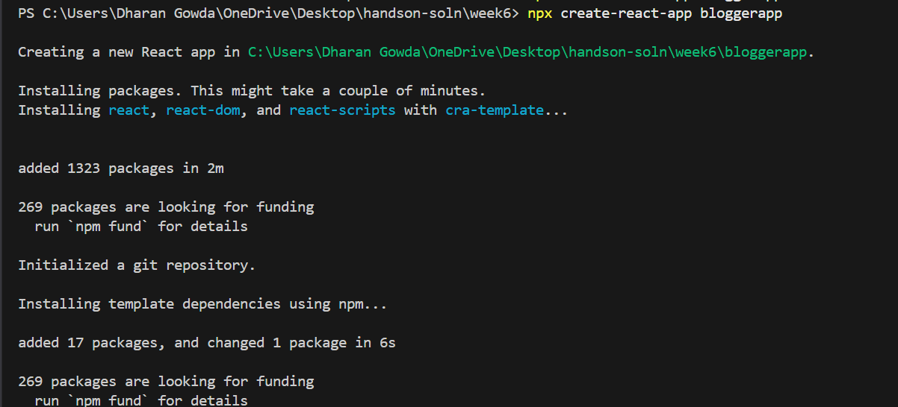

**Step 2:-code the component** **BookDetails.js**

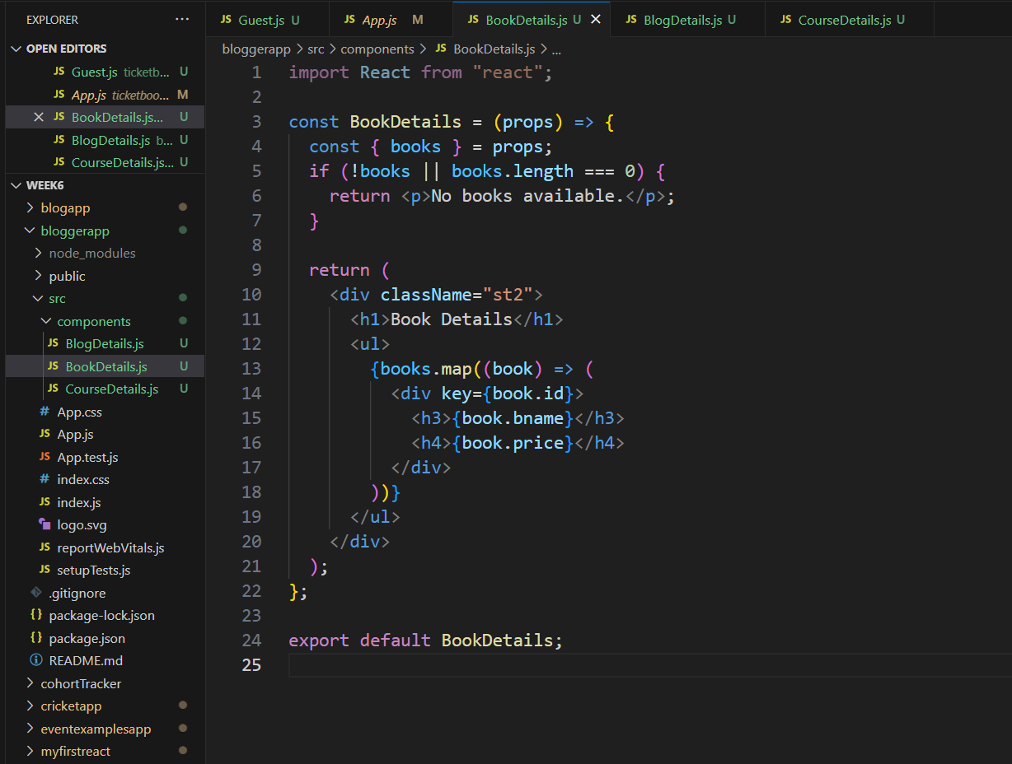

**Step 3:-code the component** **Blog Details**

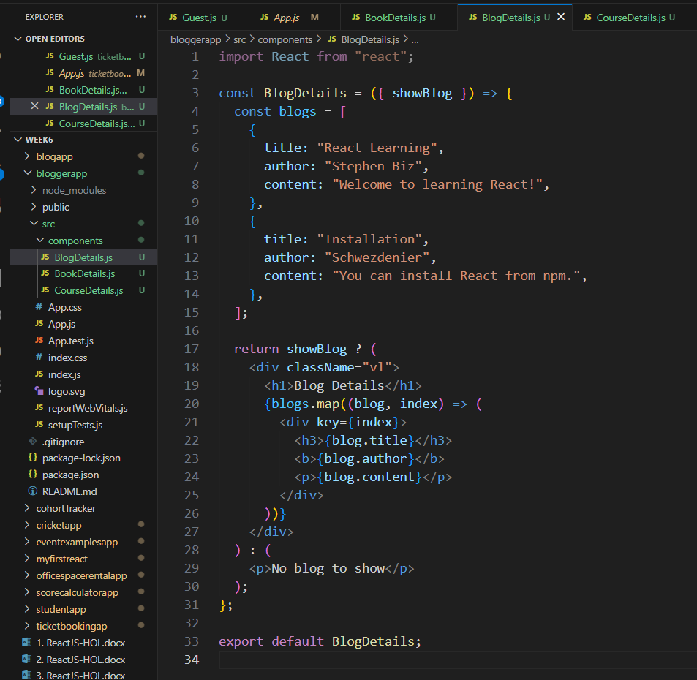

**Step 4:-code the component** **Course Details**

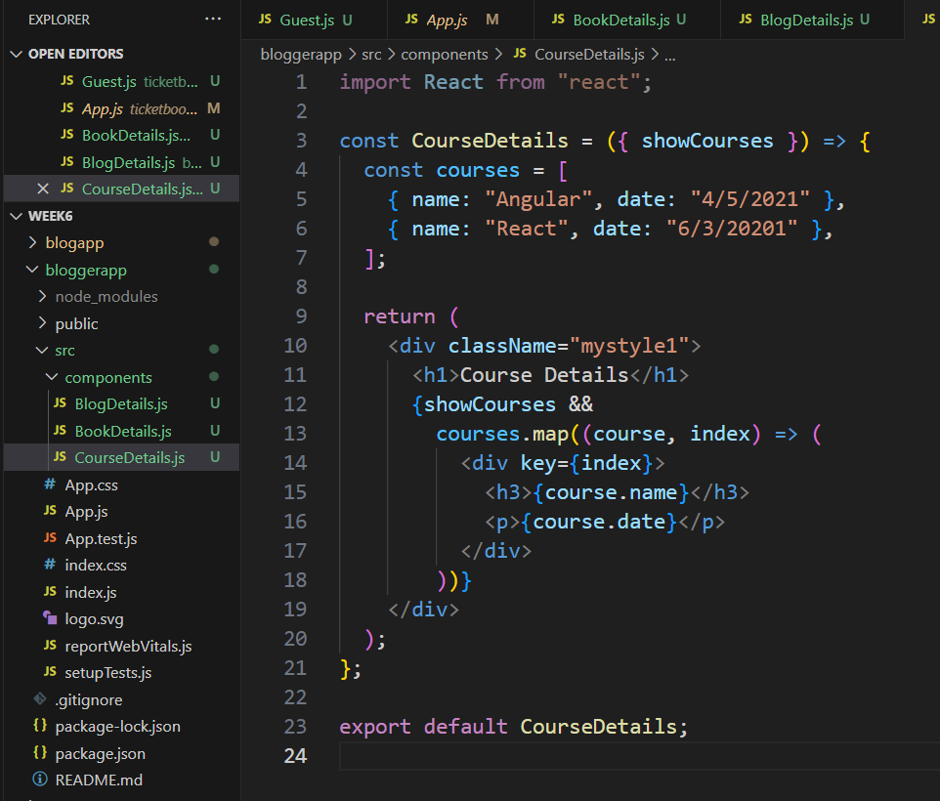

**Step 5:-code the App.js**

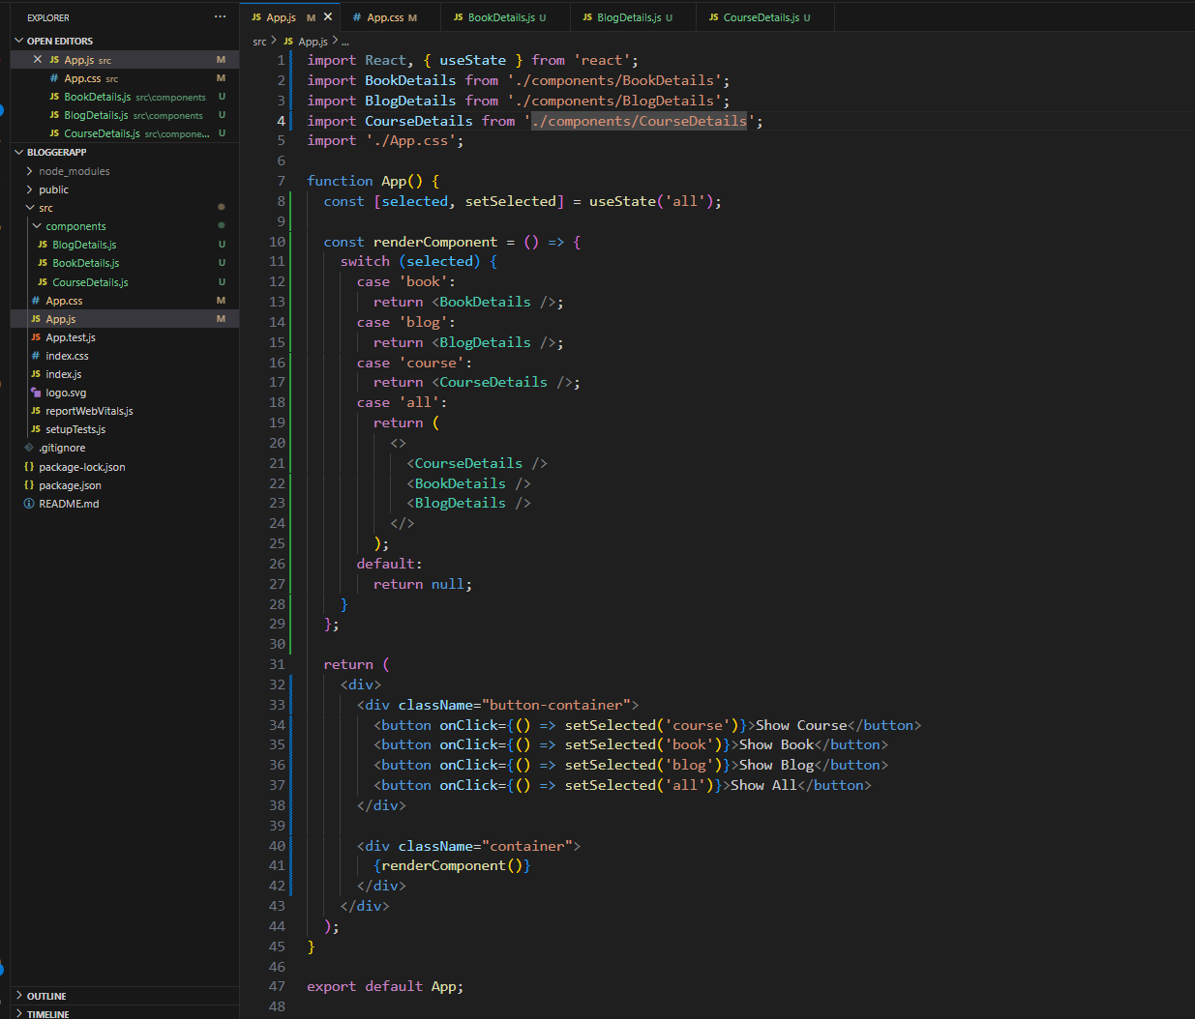

**OUTPUT:-**



